StudyQuest Testing Evidence
Course: SDEV265
Tester: Harold
Platform: Windows-11-10.0.26100-SP0
Python Version: 3.13.12
Test Date: March 04, 2026

Testing Environment
Application Being Tested: StudyQuest_v3.1.py
Save File Used: ~/.studyquest/studyquest_save.txt
Evidence Type: Screenshots captured while running tests

Test Case — Application Launch Prompt
Purpose | Verify the application prompts the user for a profile name on first launch.
Result | PASS
Explanation | The Windows build opens with a name prompt first, after entering a name, the app opens cleanly without any startup issues.
Evidence | See screenshot below.

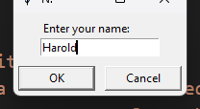
Figure 1: StudyQuest launch prompt requesting the player's name.

Test Case — Save File Loading and Main Interface
Purpose | Confirm that saved player data and goals load into the Windows Tkinter interface correctly.
Result | PASS
Explanation | The saved profile loads the way it should. Level, XP, tasks, and habits all show up in the main window right away.
Evidence | See screenshot below.

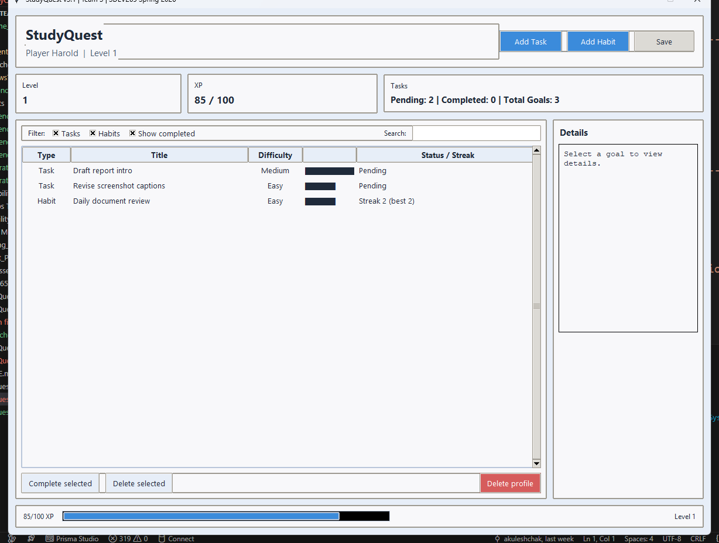
Figure 2: Main interface

Test Case — Add Task Dialog
Purpose | Verify that the task creation dialog opens correctly and exposes the expected input controls.
Result | PASS
Explanation | The Add Task window opens normally and shows the fields you would expect for title, description, difficulty, and an optional due date.
Evidence | See screenshot below.

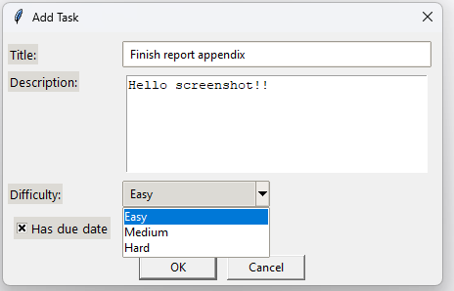
Figure 3: Add Task dialog on Windows.

Test Case — Task Completion and XP Progression
Purpose | Verify that completing a task updates the task state and player XP values.
Result | PASS
Explanation | After marking the task complete, the goal moves to completed and the XP and level display update in the main window like they should.
Evidence | See screenshot below.

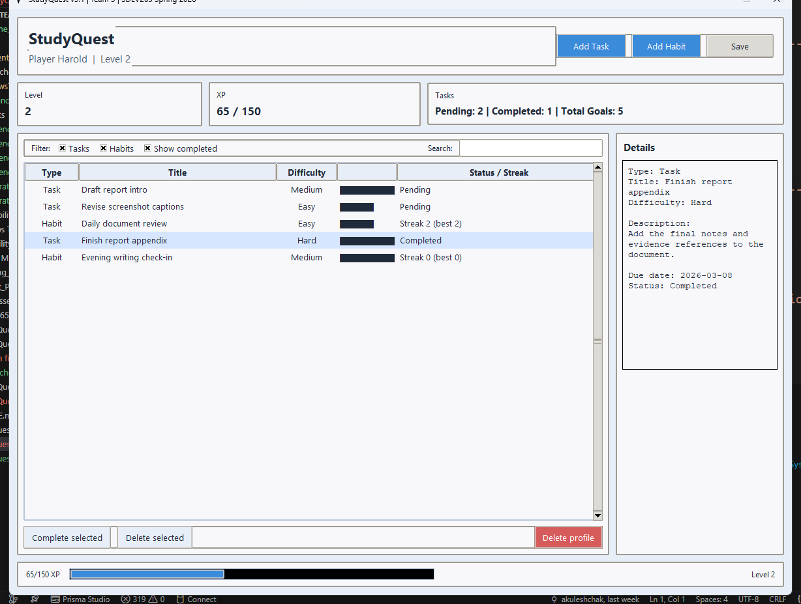
Figure 4: Updated XP and completed task state after task completion.

Test Case — Habit Tracking and Filtering
Purpose | Verify that habit streak data appears correctly and that the filter controls narrow the visible results.
Result | PASS
Explanation | The filters work as expected here. With tasks hidden, completed items shown, and a search term added, the window narrows down to the habit view cleanly.
Evidence | See screenshot below.

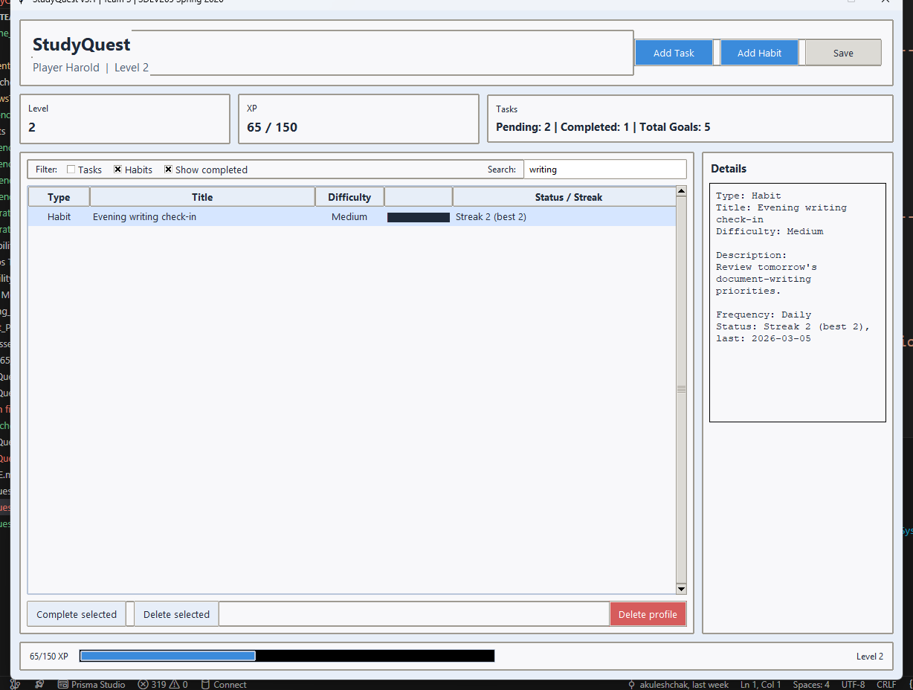
Figure 5: Habit streak details and filtered results

Test Case — Save Persistence After Relaunch
Purpose | Verify that saved progress continues after the application is closed and reopened on Windows.
Result | PASS
Explanation | After saving and reopening, the app brings back up the same profile, completed items, and progress from the save file.
Evidence | See screenshot below.

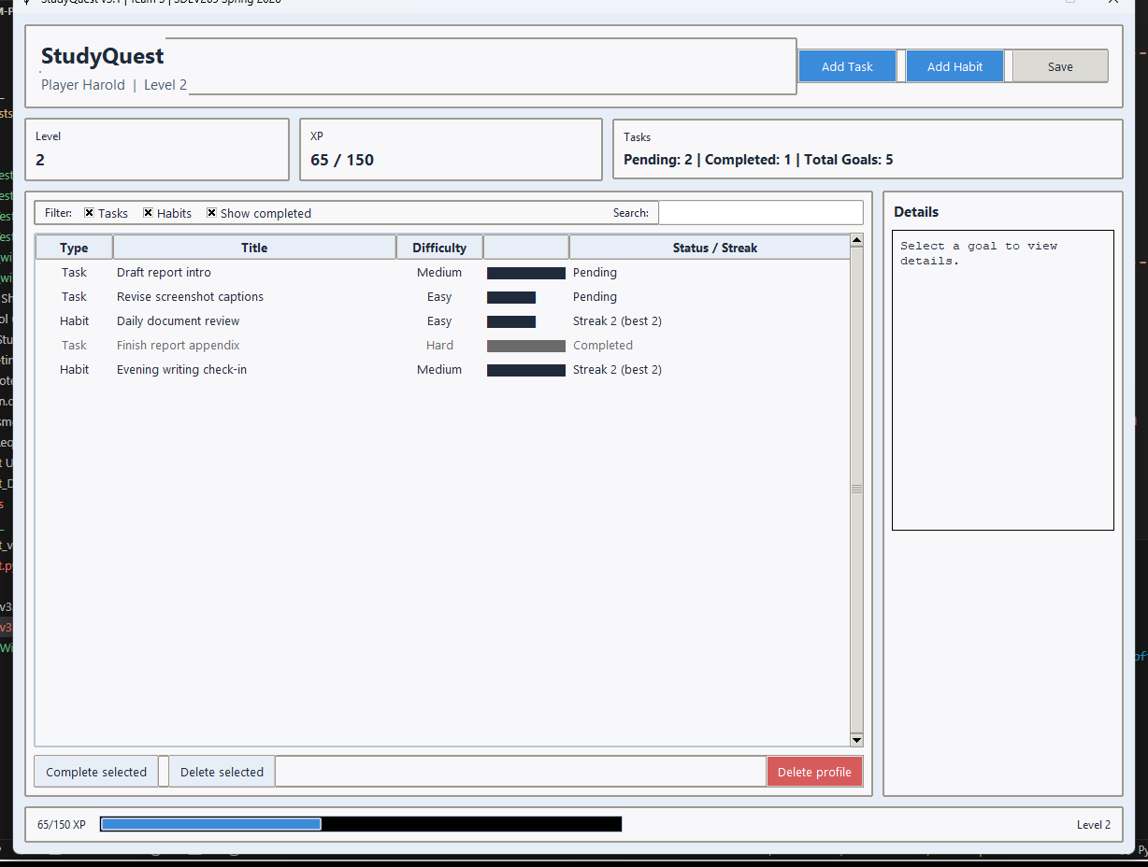
Figure 6: Relaunched interface showing continued progress loaded from disk.

Windows Test Summary
Suite | Result | Tests Run | Notes
Frontend Windows Tests v3.1 | PASS | 9 | OK
Backend Windows Tests v3.1 | PASS | 20 | OK

Overall Testing Summary
The Windows v3.1 test run came out clean. The updated interface loads correctly, task and habit flows work the way they should, XP updates show up properly, and saved progress is still there after relaunch. The backend suite still has expected-failure cases that document known gaps instead of unexpected failures.

